LOWA Sustainability Awards 2024

*For innovative waste reduction initiatives*

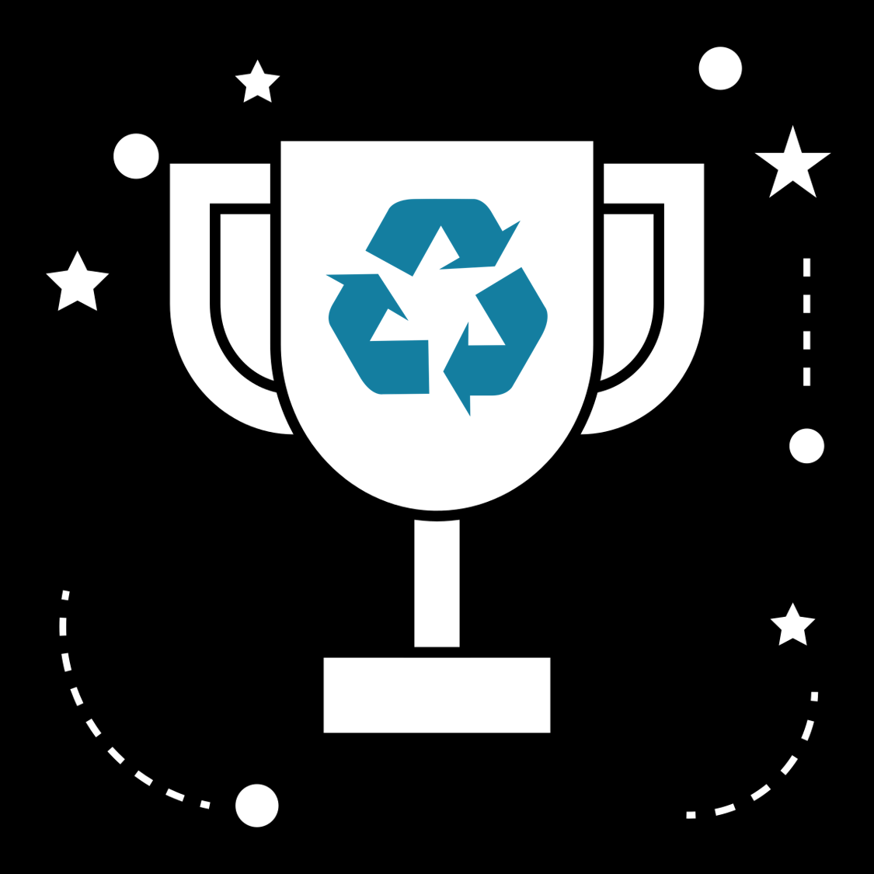

**APPLICATION FORM**

**LOWA Sustainability Awards 2024**

Please send the completed application form to [info@projectpromise.eu](mailto:info@projectpromise.eu) by

**29 February 2024.** For more information and if questions remain, don’t hesitate to contact us at [info@projectpromise.eu](mailto:info@projectpromise.eu) .

**Name of the company / firm / organisation**

|  |
| --- |
|  |

**Country**

|  |  |  |
| --- | --- | --- |
| **Maldives** | **Sri Lanka** | **India** |
|  |  |  |

**City, State / provinces**

|  |
| --- |
|  |

**Contact Details**

|  |  |
| --- | --- |
| Contact person & designation: |  |
| Email address: |  |
| Phone number: |  |

**Sector**

|  |  |
| --- | --- |
| Guesthouse / hotels |  |
| Liveaboards / houseboats |  |
| Food and beverage |  |
| Restaurants |  |
| Recreational centers |  |
| Others (please specify) |  |

**Company size**

|  |  |
| --- | --- |
| Number of employees: |  |
| Annual Revenue *(in local currency)*: |  |
| Capacity:  *(Rooms/seating/output per day)* |  |

**Application category** (*select a category and explain how you are eligible for selected category*)

|  |  |  |  |  |
| --- | --- | --- | --- | --- |
| Micro or small |  |  | Large or medium |  |
| Justification for eligibility |  |  | Justification for eligibility |  |

**What initiative/s were taken to minimise waste at your premises in 2022-2023?**

*Describe each initiative in maximum 100 words. It can be more than one. Add more rows as needed*

|  |  |
| --- | --- |
| Type of waste reduced | Description of initiative taken |
|  |  |
|  |  |

**What was the motivation for this waste minimising initiative/s?**

*Describe in maximum 100 words.*

|  |
| --- |
|  |

**Explain the innovation in waste minimising initiative/s**

*Describe in maximum 100 words.*

|  |
| --- |
|  |

**Impacts of initiative/s**

*Please fill in all the following fields*

|  |  |  |  |  |
| --- | --- | --- | --- | --- |
| Type of waste | Amount reduced in 2022 | Amount reduced in 2023 | Financial Investment:  *in local currency* | Financial savings:  *in local currency* |
|  |  |  |  |  |
|  |  |  |  |  |

**What were the social benefits, if any, associated with the initiative/s?**

*Describe in maximum 75 words.*

|  |
| --- |
|  |

**What steps have been taken to reduce energy consumption in last two years (2022 and 2023)?**

*Describe in maximum 75 words.*

|  |
| --- |
|  |

**What steps have been taken to reduce water consumption in last two years (2022 and 2023)?**

*Describe in maximum 75 words.*

|  |
| --- |
|  |

**What are your future plans for waste and resource minimization?**

*Describe in maximum 75 words.*

|  |
| --- |
|  |

**Please fill in the links of photos and videos of the waste minimising initiative/s at your premises.**

*Please upload the photos and videos on google drive and paste the link below or email us to* [*info@projectpromise.eu*](mailto:info@projectpromise.eu)

|  |
| --- |
|  |

**How did you hear about the LOWA Sustainability Awards?**

|  |
| --- |
|  |

I agree that the information provided above can be used for the PROMISE project purpose.

Thank you very much for completing the application!

Please send the completed application form to [info@projectpromise.eu](mailto:info@projectpromise.eu) by **29 February 2024**.

**DISCLAIMER:** This application has been produced with the financial assistance of the European Union. The contents displayed on it are the sole responsibility of The Maldives National University (MNU) and can under no circumstances be regarded as reflecting the position of the European Union.